**M.C.E Society’s**

**Allana Institute of Management Sciences, Pune**

**Synopsis**

**On**

**Online Voting System**

**ITC11 : Mini Project**

**By**

**Idris Yusuf Mulla & Suleman Imran Sayed**

**MCA I**

**Roll No : 22 & 120**

**Academic Year 2021-2022**

**Under the Guidance of Prof. Mehdi Khundmir & Prof. Mehdi Jafri**

**ACKNOWLEDGEMENT**

The development of software is a very hard work and it is not possible without proper guidance and suggestion and this project report itself acknowledge to the sincere efforts of all individuals who have contributed for its completion.

We sincerely thank you guide Prof. Javed Khan & Prof. Mehdi Jafri, We express our gratitude, for his encouragement and support during this project. She suggested us everywhere time to time for population and successful completion of the project.

We express our deep gratitude and sincere thanks to our friend whose valuable suggestions and constant encouragement during analysis, design and coding of the project us a lot.

**Index**

|  |  |  |  |
| --- | --- | --- | --- |
| Sr. No |  | Particulars | Page No. |
| 1 |  | Abstract |  |
| 2 |  | Introduction |  |
|  | 2.1 | Motivation |  |
|  | 2.2 | Problem statement |  |
|  | 2.3 | Purpose/Objectives/goals |  |
|  | 2.4 | Literature survey |  |
|  | 2.5 | Project Scope and Limitations |  |
| 3 |  | System Analysis |  |
|  | 3.1 | Existing System |  |
|  | 3.2 | Scope and Limitation of existing system |  |
|  | 3.3 | Project perspective, features, stakeholders |  |
|  | 3.4 | Requirement Analysis |  |
|  | 3.4.1 | Functional Analysis |  |
|  | 3.4.2 | Performance Analysis |  |
|  | 3.4.3 | Security Analysis |  |
| 4 |  | System Design |  |
|  | 4.1 | Design constraints |  |
|  | 4.2 | System Model |  |
|  | 4.2.1 | Data Flow Diagram |  |
|  | 4.2.2 | Data Model |  |
|  | 4.3 | User Interface |  |
| 5 |  | Implementation Details |  |
|  | 5.1 | Software and hardware specifications |  |
| 6 |  | Output and Report Testing |  |
|  | 6.1 | Test Plan |  |
|  | 6.2 | Black Box Testing/Data validations Test cases |  |
|  | 6.3 | White Box Testing/functional validations Test cases and results |  |
| 7 |  | Conclusion and Recommendation |  |
| 8 |  | Future Scope |  |
| 9 |  | Bibliography and References |  |

**1.INTRODUCTION**

1.1 Motivation

Online Election System would have Candidate registration, document verification, auto-generated User ID and pass for candidate and Voters. Admin Login which will be handled by Election Commission. Candidate Login which will be handled By Candidate, Voters will get Unique ID and Password, Using which they can vote for a Candidate only once per Election.

1.2 Problem Statement

In current we have to go to polling booth to poll that’s very tired some and time consuming

1.3 Purpose/Objective

The project is beneficial for Election Commission, Voters as the can get to know the candidate background and choose wisely, and even for Candidate. The software system allows the Candidate to login in to their profiles and upload all their details including their previous milestone onto the system.

1.4 Literature Survey

As the world watched the electoral drama unfold in Florida at the end of 2000, people started wondering, “Wouldn’t all our problems be solved if they just used Internet Voting?”. People all over the world soon started taking a hard look at their voting equipment and procedures, and trying to figure out how to improve them [1]. There is a strong inclination towards moving to Remote Internet Voting – at least among the politicians – in order to enhance voter convenience, increase voter confidence and voter turnout. However, as will be seen later in this paper, there are serious technological and social aspects that make Remote Internet Voting infeasible in the visible future. Therefore, many technologists have suggested that remote poll-site electronic voting, where the voter can vote at any poll-site (not only his home county poll-site), seems to be the best step forward as it provides better voter convenience, but at the same time, does not compromise security. This paper presents a survey of the state of the art in Electronic Voting, including the various works done in Internet Voting (and the arguments against its use), as well as in electronic poll-site voting. Electronic voting refers to the use of computers or computerized voting equipment to cast ballots in an election. Sometimes, this term is used more specifically to refer to voting that takes place over the Internet. Electronic systems can be used to register voters, tally ballots, and record votes.

1.5 Project Scope

Fast and easy way of conducting Election.

Voters can view background of each Candidate.

Candidate can present themselves against voters.

Admin can verify the documents and details of Candidate.

System Generated Unique ID and Password gives more Secure Logins.

Result will be out after 2 Hrs of Election.

**3.System Analysis**

3.1 Existing System

In the initial system people have to go to the polling booth to make an vote that’s very tiresome process

**3.2** Scope of the system

Users are provided with a online registration form before voting user should fill online form and submit details these details are compared with details in database and if they match then user is provided with username and password using this information user can login and vote. If conditions are not correct entry will be cancelled.

3.2 PROPOSED SYSTEM

Fast and easy way of conducting Election.

Voters can view background of each Candidate.

Candidate can present themselves against voters.

Admin can verify the documents and details of Candidate.

System Generated Unique ID and Password gives Secure Logins.

Result will be out after 2 min of Election.

3.3 Project Prospective/Features

In this project we have tried our best to find best solutions to existing solution so that no one have to go through that process. In this process we have provided results under 2min and login and register is also simple and you can poll the vote concurrently but there may be some risk although

3.4 Requirement Analysis

There are some requirement which are as follows -

3.4.1 Functional Analysis

This study is carried out to check the economic impact that the system will have on the organization. The amount of fund that the company can pour into the research and development of the system is limited. The expenditures must be justified. Thus, the developed system as well within the budget and this was achieved because most of the technologies used are freely available. Only the customized products had to be purchased.

3.4.2 Performance Analysis

This study is carried out to check the technical feasibility, that is, the technical requirements of the system. Any system developed must not have a high demand on the available technical resources. This will lead to high demands on the available technical resources. This will lead to high demands being placed on the client. The developed system must have a modest requirement, as only minimal or null changes are required for implementing this system.

3.4.3 Security Analysis

The aspect of study is to check the level of acceptance of the system by the user. This includes the process of training the user to use the system efficiently. The user must not feel threatened by the system, instead must accept it as a necessity. The level of acceptance by the users solely depends on the methods that are employed to educate the user about the system and to make him familiar with it. His level of confidence must be raised so that he is also able to make some constructive criticism, which is welcomed, as he is the final user of the system.

**4.System Design**

There is use of lots of design ideas we have gone through some are in brief as below.

4.1 Design Constraints

Following the architecture presented in diagrams, a prototype for an e-Voting system has been developed.

The developed prototype makes use of two software XAMPP servers, the SQL database and the e-Voting ones.

Both of these servers run Windows NT as an operating system. The details of these servers are presented below

4.2 System Model

4.2.1 Data flow diagram

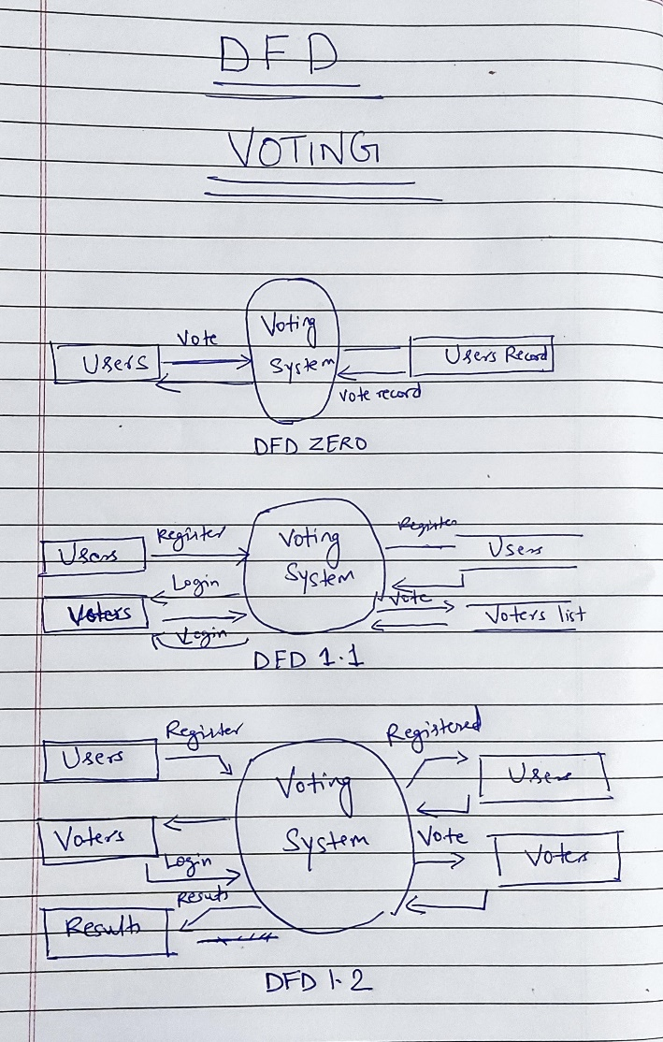

4.2.2 Data Model

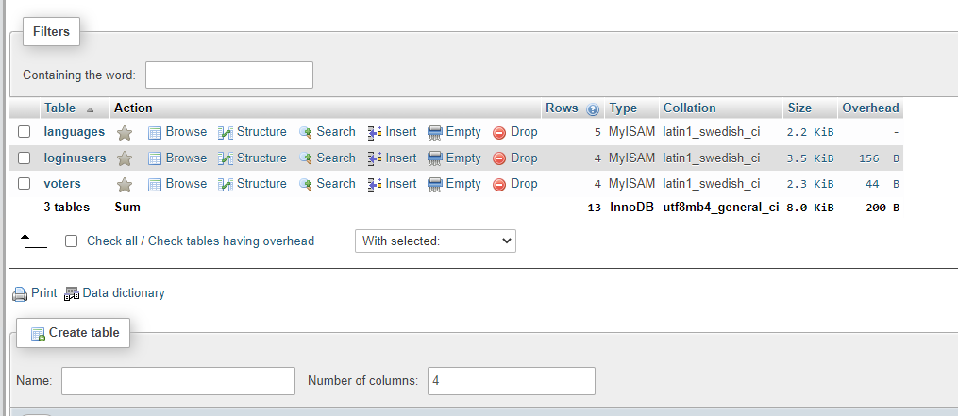

ER DIAGRAM

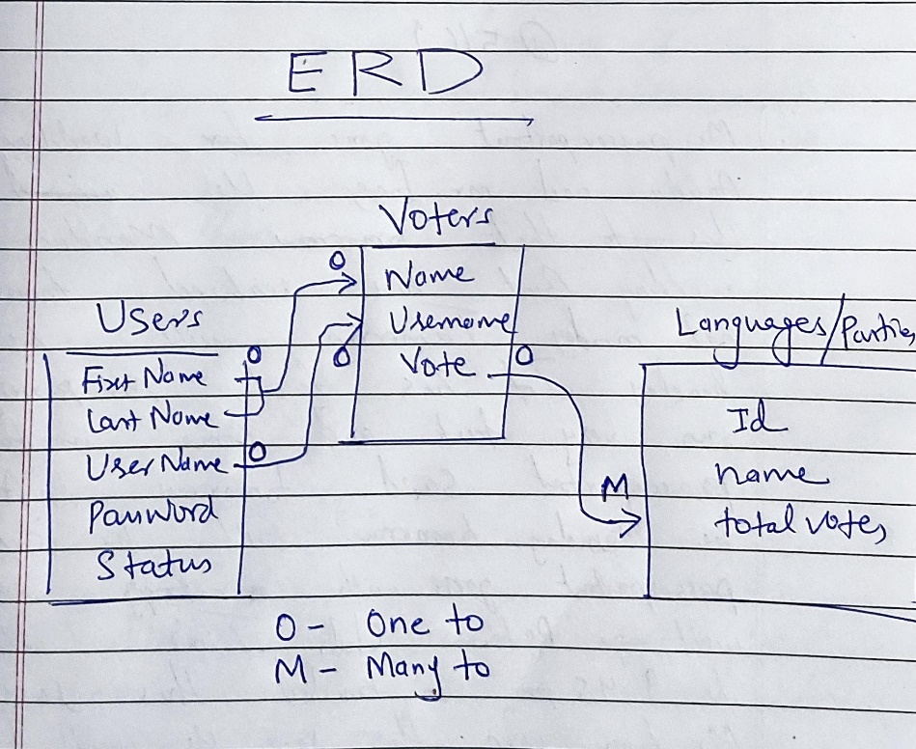

4.3 User Interface

**Home Screen**

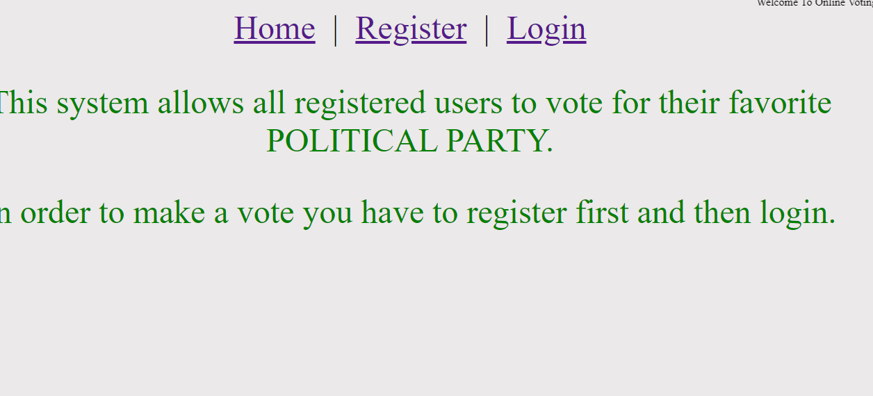

**Login**

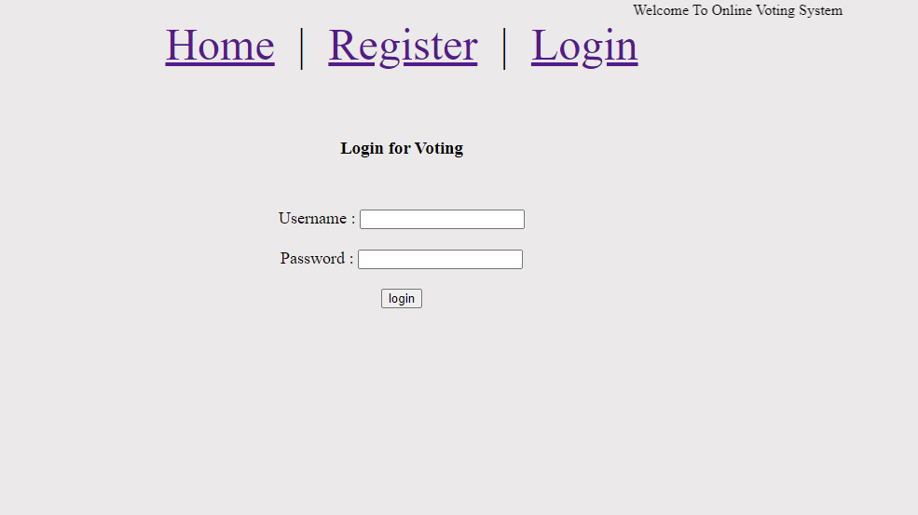

Sign Up

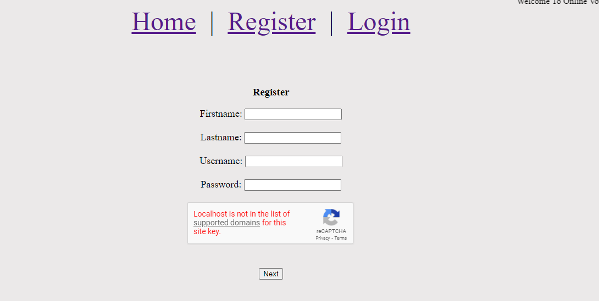

**Voting screen**

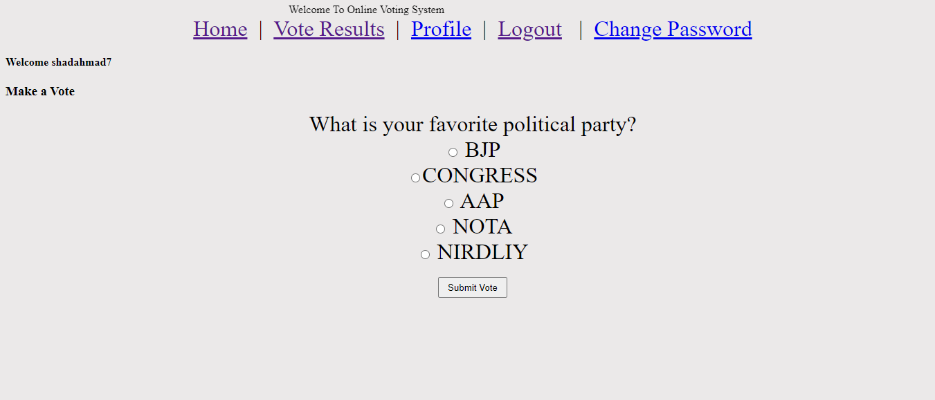

**Results**

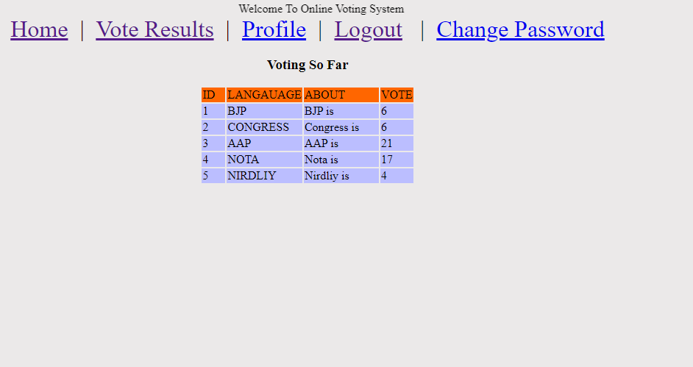

Technology Used : PHP & HTML (FRONT END)

CSS & JS (BACK END)

Software and hardware requirements

Software –

XAMPP,

My SQL DB

Apache Server

PHP and HTML, CSS and JS.

Hardware –

PC or Laptop

4gb ram

Hard disk -30 GB

I3 intel or above

**6. Output and Report Testing**

6.1 Test Plan

The testing can be done at system, integration and unit levels of software development. One of the basic goals of white box testing is to verify a working flow for an application. It involves testing a series of predefined inputs against expected or desired outputs so that when a specific input does not result in the expected output, you have encountered a bug.

6.2 White Box Testing

**White Box Testing** is software testing technique in which internal structure, design and coding of software are tested to verify flow of input-output and to improve design, usability and security. In white box testing, code is visible to testers so it is also called Clear box testing, Open box testing, Transparent box testing, Code-based testing and Glass box testing.

It is one of two parts of the Box Testing approach to software testing. Its counterpart, Blackbox testing, involves testing from an external or end-user type perspective. On the other hand, White box testing in software engineering is based on the inner workings of an application and revolves around internal testing.

6.3 Black Box Testing

The term Black Box was used because of the see-through box concept. The clear box or White Box name symbolizes the ability to see through the software’s outer shell (or “box”) into its inner workings. Likewise, the “black box” in [Black Box Testing](https://www.guru99.com/black-box-testing.html) symbolizes not being able to see the inner workings of the software so that only the end-user experience can be tested.

**7. Conclusion & Recommendation**

In this PROJECT, we have described the introduction about system analysis and design. We discuss the result of software requirements by functional requirement, non-functional requirement. Furthermore, we also explained use case diagram which consists of two description actor and use case. Finally, we describe the architecture design phase through system design.

**11. Future Scope**

Risk related to security (computer viruses/hacker) that could compromise an election and public confidence.

Problems with access to the Internet through the digital divide based on socio-economic variables and between rural and urban areas.

Greater opportunity for fraud or coercion, potentially violating ballot integrity.

Issue of voter education: time and money must be invested to ensure public is aware that electronic/Internet voting is an option.

**12.BIBLIOGRAPHY**

1.Google

2.Web Blogs

3.Youtube

4.Subject Teachers

5.Senior Friends

Student’s Mobile no. 7507897967 / 7020523129

Guardian’s phone number 8766091083 / 8888346123

Email Id : [idrism416@gmail.com](mailto:idrism416@gmail.com) / sulemansayed2000@gmail.com

Permanent Address C-17, Durrani Complex, Mithanagar, Kondhwa Pune -411048

B2 – 103 H&M Royal, Parge Nagar, Kondhwa Pune – 411048